**UI**

major modules:

* login page
* registration page
* main UI

sequence diagram:

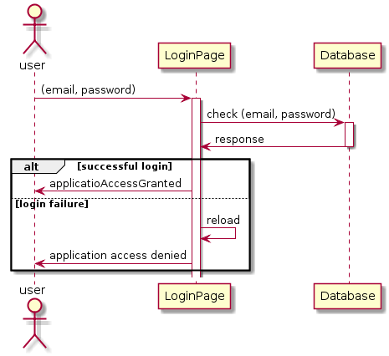

Data description

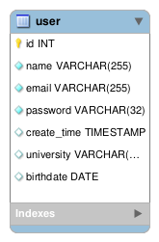

screenshot of application design:

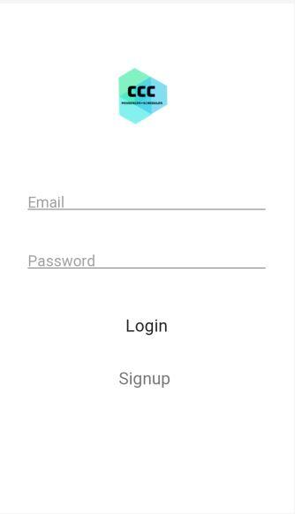

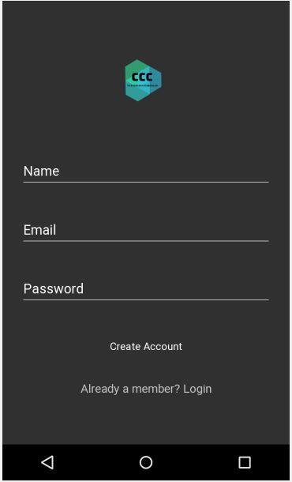

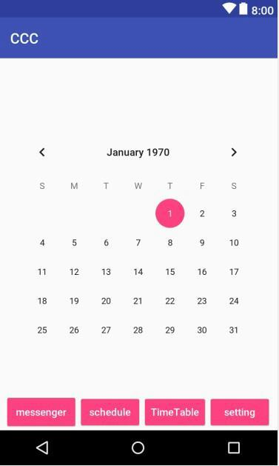

Pros :

* Simple , Lucid design of Login and Signup Pages
* Using Tabbed Menu lets User
* It makes it easy to find the current location of entry.
* It allows designer to jump frequently among all entries without losing direction.
* It shows directly the contents of the most important entry.

Cons:

* Not good for too many entries.

test plan:

|  |  |
| --- | --- |
| Back button | Verify that the back button open the previous page of our application. |
| Switch between screens | Check that switching between calendar and chat works well. |
| Login page | ensure that the login page correctly check the user identity |
| Registration page | ensure that the page correctly create user |